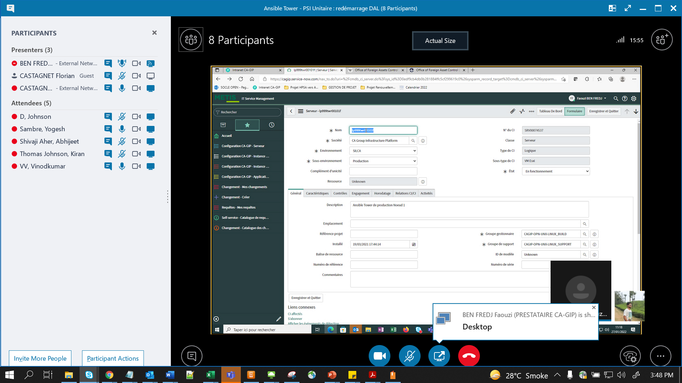

Bi Site

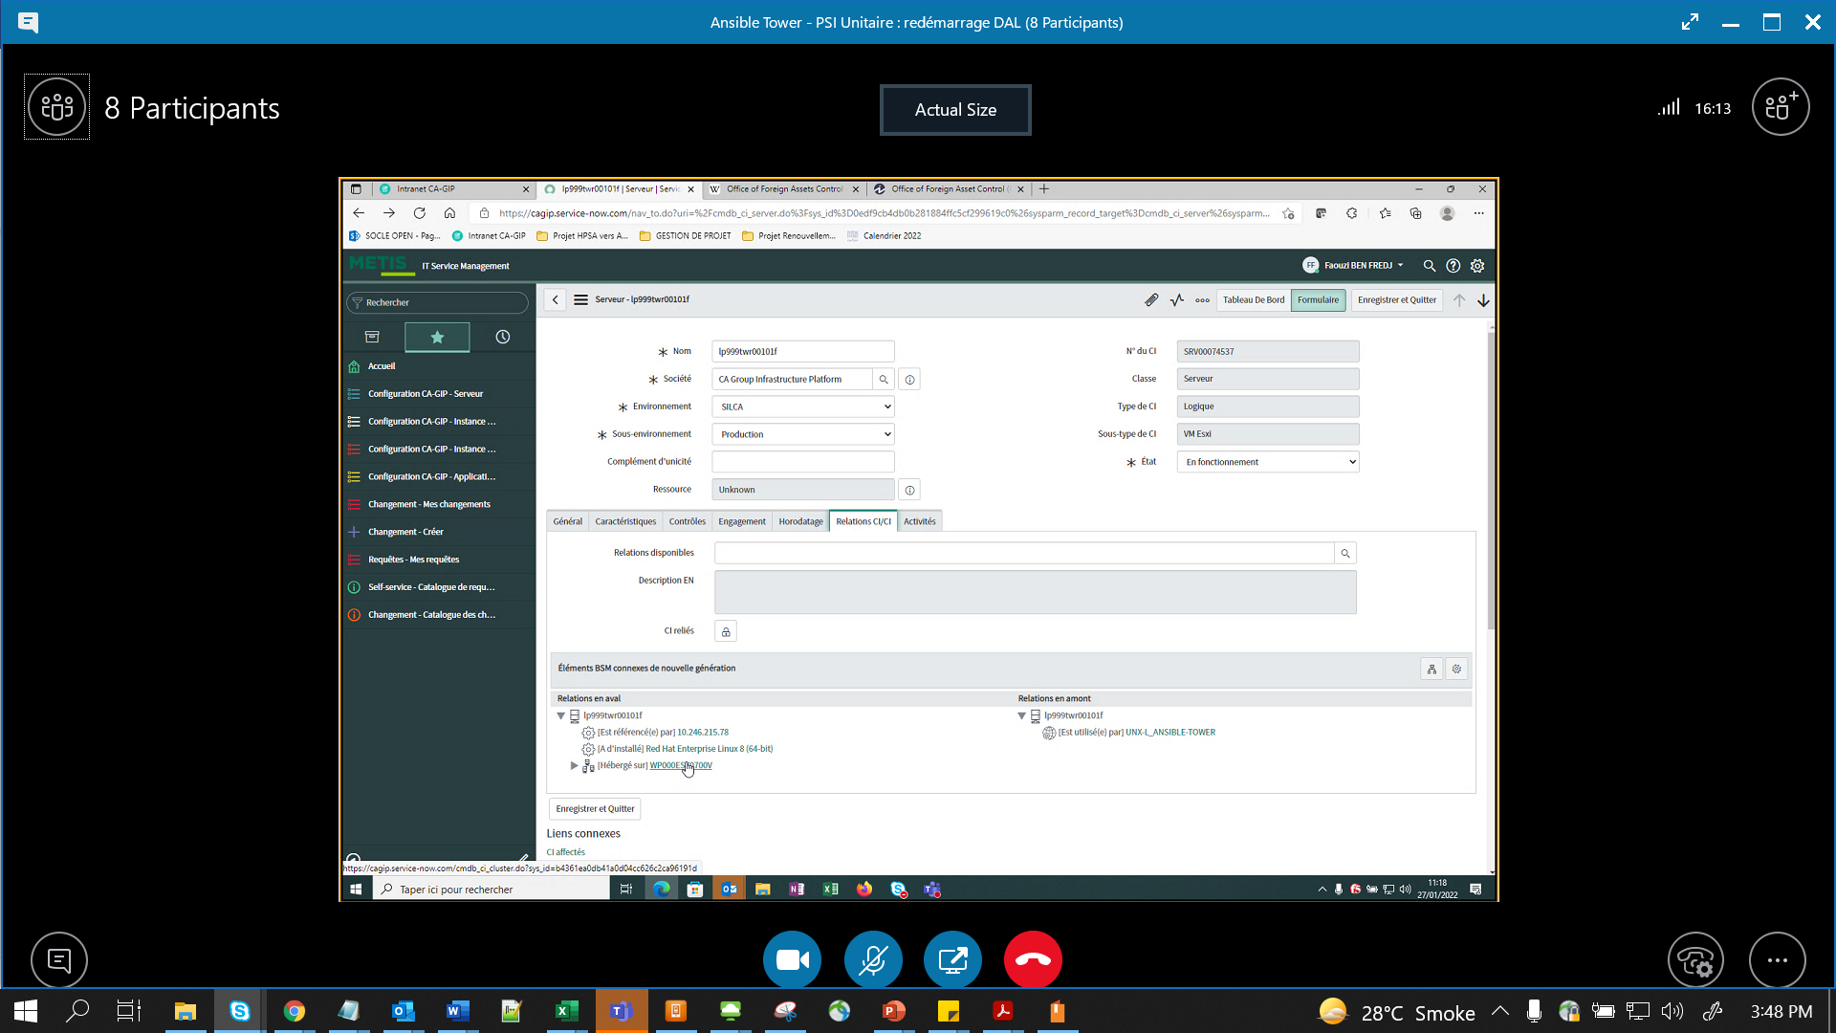

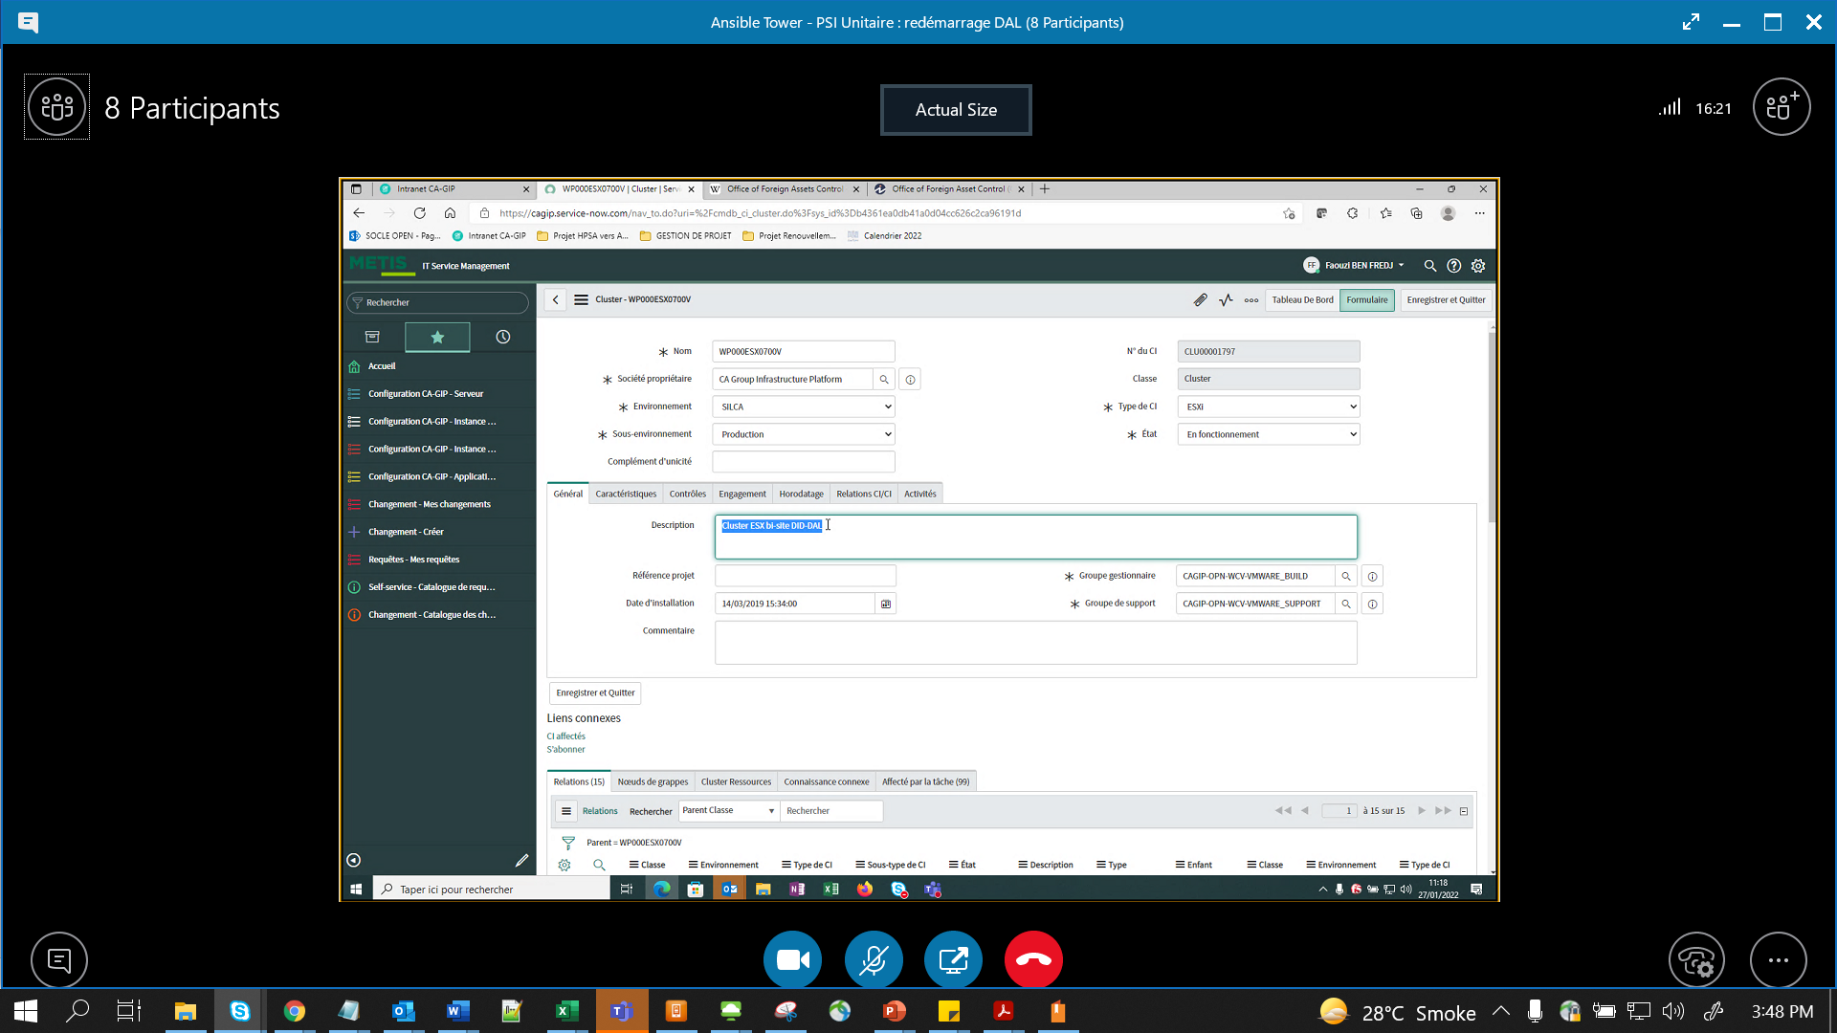

So it will be covered in NoV PSI

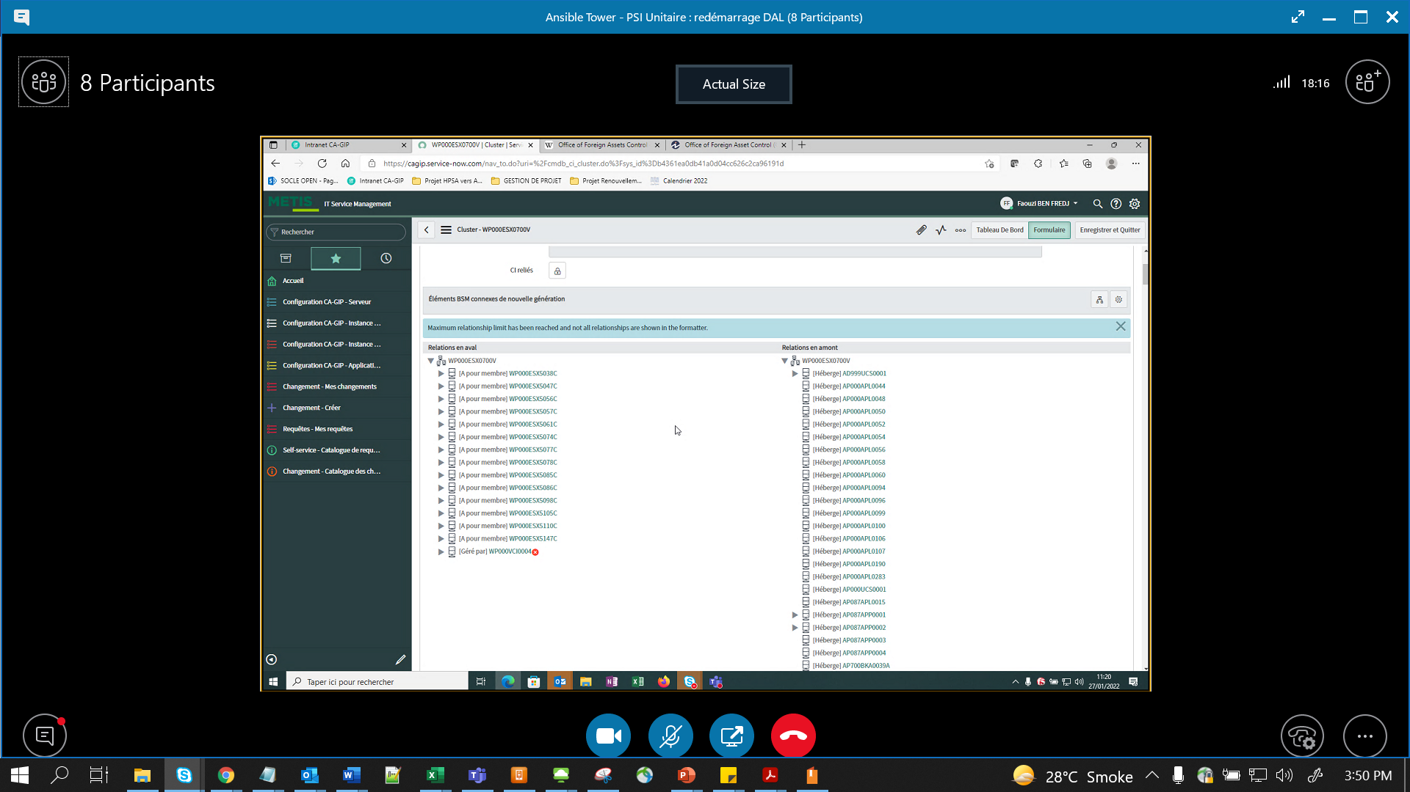

Build teamwill add(ask to add ) these Ans Twr (Mono site wala) too to be included in May PSI

|  |  |  |  |  |  |  |  |
| --- | --- | --- | --- | --- | --- | --- | --- |
| **hostname** | **Site** | **VM Critique** | **Composant** | **PSI test : VMs stop date** | **PSI test : VMs restart date** | **Change** | **Status** |
| Lp999twr00001 | Bi-site | oui | Automation Hub | Done during November PSI because bi-site | |  |  |
| lp999twr00101f | Bi-Site | oui | Tower | Done during November PSI because bi-site | |  |  |
| lp999twr00102f | DAL | non | Tower | 25/01/2022 | 27/01/2022 | CAGIPCHG0073259 | VMs restart In Progress |
| lp999twr00103f | DID | non | Tower | 18/01/2022 | 20/01/2022 | CAGIPCHG0073250 | DONE |
| lp999twr00104f | DAL | non | Tower | 25/01/2022 | 27/01/2022 | CAGIPCHG0073259 | VMs restart In Progress |
| lp999twr00105f | DID | non | Tower | 18/01/2022 | 20/01/2022 | CAGIPCHG0073250 | DONE |
| lp999pos0005 | Bi-site | oui | PostgreSQL | Done during November PSI because bi-site | |  |  |

After Server power off or on, VIP to be checked (URL for checking it to be provided by Build team)

& slice number to be increased from 3 to 5 (when On) { While powering off – Slicing will be changed from 5->3}